**LIT TRAINING**

**Batch Name : SAP ABAP ON HANA** **DAY 14 ASSIGNMENT**

**EMPLOYEE ID – 46255260**

**CDS-Assignment 1 – Create a Simple CDS view with Date Functions in ABAP CDS Views**

**CODE:**

@AbapCatalog.sqlViewName: 'ZLITVIEW'

@AbapCatalog.compiler.compareFilter: true

@AbapCatalog.preserveKey: true

@AccessControl.authorizationCheck: #NOT_REQUIRED

@EndUserText.label: 'CDS VIEW OF LIT'

**define** **view** Z46255244LIT_CDS **as** **select** **from** vbak **{**

  vbeln **as** Sales_Document**,**

  auart **as** Sales_Document_Type**,**

  audat **as** Document_Date**,**

  vdatu **as** Requested_delivery_date**,**

  DATS_DAYS_BETWEEN**(**audat**,** vdatu**)** **as** no_of_days**,**

  DATS_ADD_DAYS**(**vdatu**,** 10**,** 'NULL'**)** **as** shipping_date**,**

  DATS_ADD_MONTHS**(**vdatu**,** 2**,** 'NULL'**)** **as** billing_date

**}**

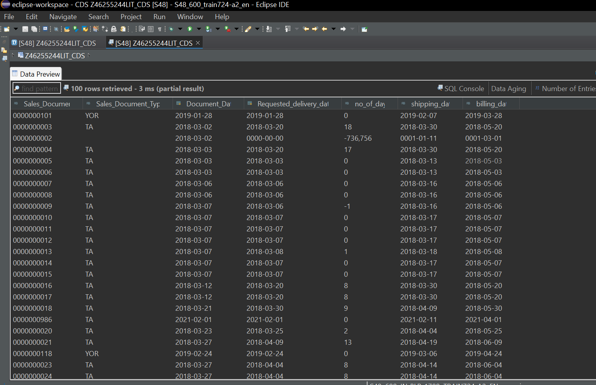

CDS-Assignment 2 – Create a Simple CDS view with String Functions in ABAP CDS Views

CODE:

@AbapCatalog.sqlViewName: 'Z24_STRING'

@AbapCatalog.compiler.compareFilter: true

@AbapCatalog.preserveKey: true

@AccessControl.authorizationCheck: #NOT_REQUIRED

@EndUserText.label: 'CDS VIEW WITH STRING FUNCTIONS'

**define** **view** Z46255244LIT_CDS1 **as** **select** **from** kna1 **{**

kunnr **as** Customer_Number**,**

land1 **as** Country_Key**,**

CONCAT**(**name1**,** name2**)** **as** Full_Name**,**

CONCAT_WITH_SPACE**(**stras**,** ort01**,** 4 **)** **as** COMBO**,**

left**(**name1**,** 2**)** **as** F2C_NAME1**,**

RIGHT**(**name1**,** 3**)** **as** L3C_NAME2**,**

LENGTH**(**telf1**)** **as** NAME_LENGTH**,**

SUBSTRING**(**name1**,** 2**,** 4**)** **as** SUB**,**

LTRIM**(**kunnr**,** '0'**)** **as** l_TRIM**,**

RTRIM**(**telf1**,** '4'**)**  **as**  R_TRIM

**}**

**OUTPUT:**

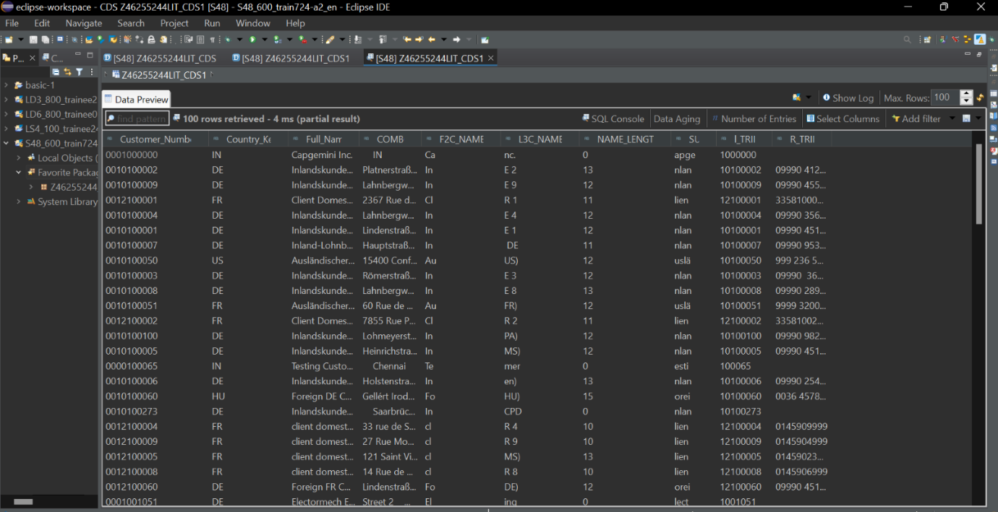

CDS-Assignment 3 – Create a Simple CDS view with Parameters

CODE:

@AbapCatalog.sqlViewName: 'Z24_PARMS'

@AbapCatalog.compiler.compareFilter: true

@AbapCatalog.preserveKey: true

@AccessControl.authorizationCheck: #NOT_REQUIRED

@EndUserText.label: 'WITH PARAMETERS'

**define** **view** Z46255244LIT_CDS2

**with** **parameters** S_PSWSL **:** *abap***.***cuky***(**5**)**

**as** **select** **from** bseg **{**

**\***

**}where** pswsl **=** **$parameters.**S_PSWSL**;**

OUTPUT:

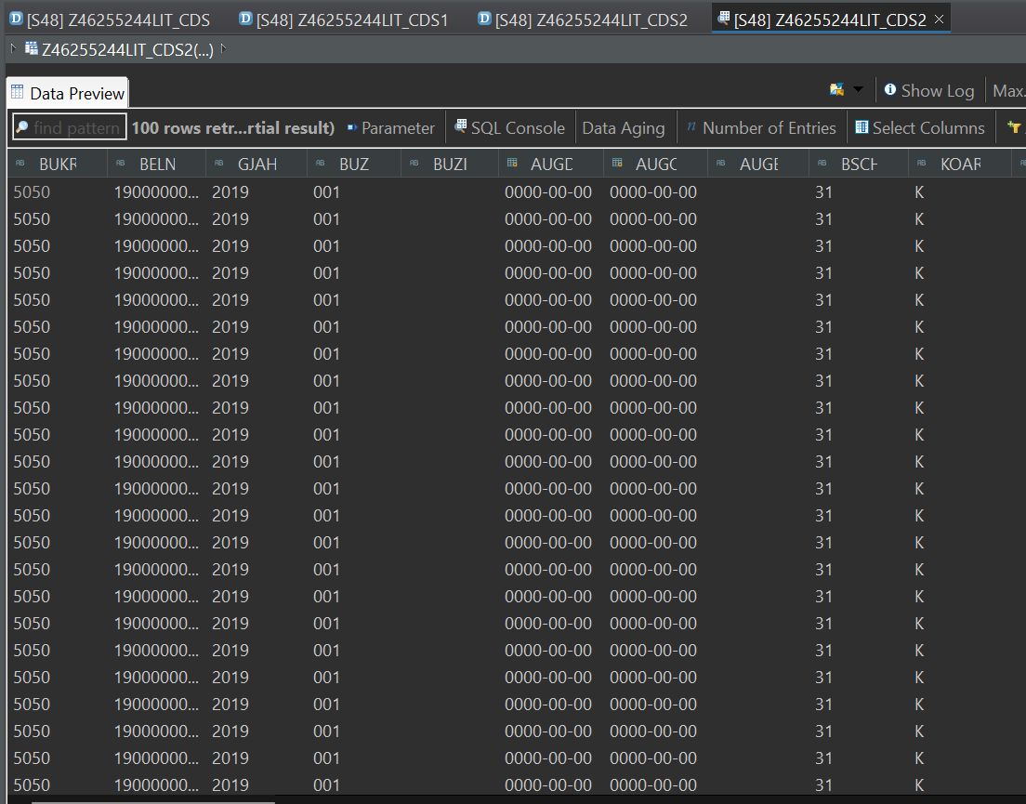

AMDP-Assignment 1 – Procedures - create a basic procedure to fetch data with scalar variable

**CODE:** **CLASS**

CLASS z46255244lit_class DEFINITION public.

  PUBLIC SECTION.

  types: begin of s_str,

        vbeln type vbap-vbeln,

        matnr type vbap-matnr,

        zmeng type vbap-zmeng,

        end of s_str.

  types : t_str type STANDARD table of S_STR.

  interfaces : if_amdp_marker_hdb.

  methods : get_method exporting value(i_out) type t_str .

  endclass.

CLASS z46255244lit_class IMPLEMENTATION.

method get_method by database procedure for HDB

language sqlscript options read-only USING VBAP .

i_out =

    select VBELN, MATNR, ZMENG FROM vbap;

endmethod.

ENDCLASS.

**PROGRAM**

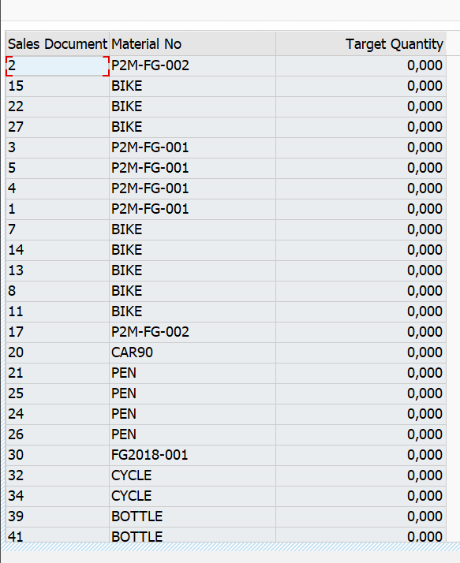

AMDP-Assignment 2 – Procedures - create a basic procedure with Table

**CLASS:**

CLASS z46255244lit_class1 DEFINITION PUBLIC.

  PUBLIC SECTION.

  types: begin of ty_tab,

        vbeln type vbak-vbeln,

        vkorg type vbak-vkorg,

        matnr type vbap-matnr,

        zmeng type vbap-zmeng,

        end of ty_tab.

  types : tt_out type table of ty_tab.

  interfaces : if_amdp_marker_hdb.

methods : get_method1

importing value(im_matnr) type vbap-matnr

exporting value(I_OUT) type tt_out.

  endclass.

CLASS z46255244lit_class1 IMPLEMENTATION.

method get_method1 by database procedure for HDB

language sqlscript options read-only USING VBAP vbak .

i_out =

    select a.VBELN, a.vkorg, b.matnr, b.zmeng FROM vbak as a inner join

    vbap as b on a.vbeln =  b.vbeln where b.matnr = im_matnr;

endmethod.

ENDCLASS.

**SE38-CODE**

REPORT z46255244lit_amdp1.

parameters : s_matnr type vbap-matnr.

DATA : c_obj TYPE REF TO Z46255244LIT_CLASS1,

       t_out TYPE REF TO cl_salv_table.

CREATE OBJECT c_obj.

c_obj->get_method1(

  EXPORTING

    im_matnr = s_matnr

  IMPORTING

    i_out    = data(ref)

).

TRY.

CALL METHOD cl_salv_table=>factory

IMPORTING

r_salv_table = t_out

CHANGING

t_table = ref

.

CATCH cx_salv_msg .

ENDTRY.

t_out->display( ).

**OUTPUT:**

